QATAR MUSEUMS PRESENTS BREADTH OF
PARTNER EXHIBITIONS AND COMMISSIONS AS PART OF DESIGN DOHA

DOHA, 27 February 2024 — Qatar Museums has revealed a wide array of partner exhibitions and commissioned works as part of Design Doha.

The biennial showcase for excellence and innovation in the design community in Qatar and the MENA region has kicked off with a week of special events and exhibition openings running until 28 February 2024, with programming running through 5 August 2024.

Established under the leadership of Qatar Museums’ Chairperson, Her Excellency Sheikha Al Mayassa bint Hamad bin Khalifa Al Thani, Design Doha will be a new platform for practitioners from across the Arab world, helping to build professional pathways and engage with the acclaimed design professionals from around the world who will convene at the event.

Design Doha events are taking place within Msheireb, a creative neighbourhood that nurtures collaboration, creativity, and innovation and is serving as host for the event.

The commissions which will be presented as part of Design Doha are:

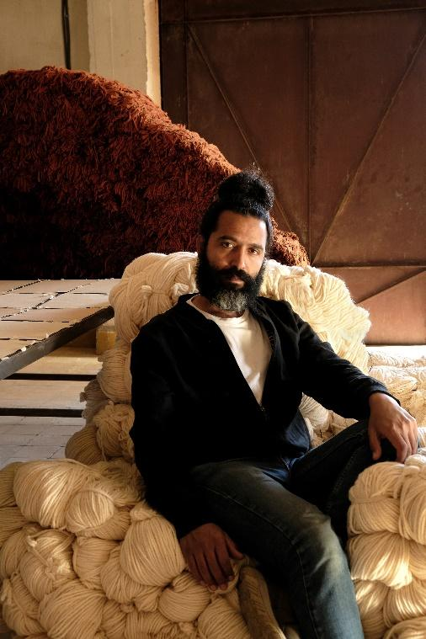 | Desert by Amine El Gotaibi  The Ned  For the first iteration of the Design Doha Biennale Amine El Gotaibi’s commission Desert will be on-view in the central atrium of the Ned Hotel, Doha, for which it is a site-specific piece. The individual strands of wool in Desert hold narratives and memories of the desert and its communities. Each piece of wool cascades from strands of copper, which are constantly shifting, changing colour, in motion, and responding to the environmental conditions. Amine El Gotaibi is a Moroccan fine artist who identifies strongly as a maker of the continent of Africa and within the MENA region. He has a thriving multi-disciplinary studio practice located in Marrakech, and his work traverses the practices and borders of craft, sculpture, and multi-disciplinary communities and narratives of making.
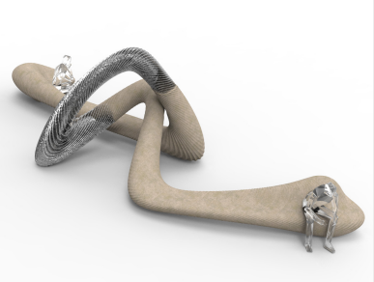 | Doha Dragon by Joris Laarman  Msheireb  The pathbreaking Dutch designer Joris Laarman finds new aesthetic possibilities in the promise of new technology. His monumental Doha Dragon is made using an innovative method called MX3D, an additive manufacturing technique of his own invention, in which metal is gradually deposited along a predetermined curvature using a robotic arm. This allows for the creation of unprecedented sculptural shapes, each with its own unique aesthetic. Laarman has used the process to create furniture, industrial components, even a whole bridge. Here, he combines it with 3D-printed sand, responsibly sourced from Qatar’s desert landscape. The serpentine form, partly inspired by industrial heat exchangers Laarman has made using Mx3D, is like that of a fantastical beast which has arrived from the near future.
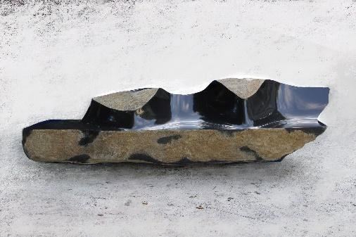 | Afterimage of the Beginning by Choi Byung Hoon  National Museum of Qatar  One of South Korea’s most revered artists, Choi Byung Hoon is a master sculptor and honored teacher of younger generations. These seating sculptures are among his most ambitious achievements. Inspired by Neolithic artworks and ancient Korea standing stones, they are carved from Indonesian black basalt. Choi has left the stone partly unaltered to convey its rough beauty, partly carved to a smooth, shining finish. The largest of the forms, a monolith fully five meters in length, is the largest work he has ever completed in basalt. Yet there is also a humility to these works: as Choi says, they are “part of nature, rather than conquering it.”

The exhibitions which will be presented as part of Design Doha are:

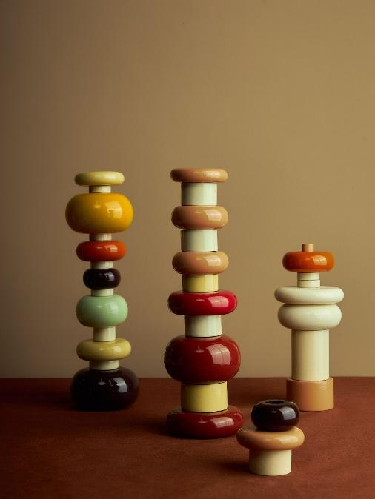 | “Room of Azerbaijan”  M7 - Profiles Café | 24 – 28 February 2024  A pop-up exhibition by CHELEBI, a homeware brand by artist Aida Mahmudova, exhibits several unique furniture pieces and ceramics at celebrating Azerbaijan’s unique cultural narrative through design, flavours, food, art, historical legacy, and traditional crafts, providing a fresh view of the country’s visual identity, bringing together tradition and modernity.
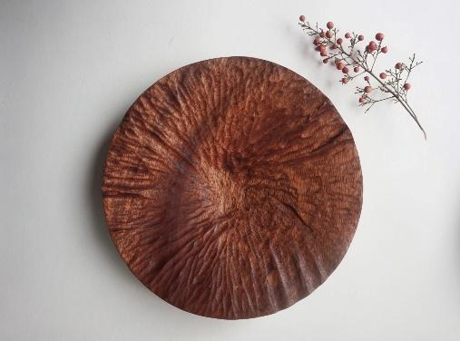 | “Craft and Symbol: The Evolution of Contemporary Design in Turkey”  Galleria, Msheireb Downtown Doha | 24 – 28 February 2024  Turkish designer Gökhan Karakuş explores the essence of craft and the beauty of imperfection within modern Turkish design, set within the context of a traditional apartment's wood and stone backdrop. Focusing on the process of creation, the exhibition emphasises collaboration between the designer and craftspeople to highlight the physical and symbolic aspects of crafting. Karakuş is particularly interested in the contributions of the new generation of designers, whose work has prompted him to reconsider the significance of symbols, representation, and iconography in Turkish design.
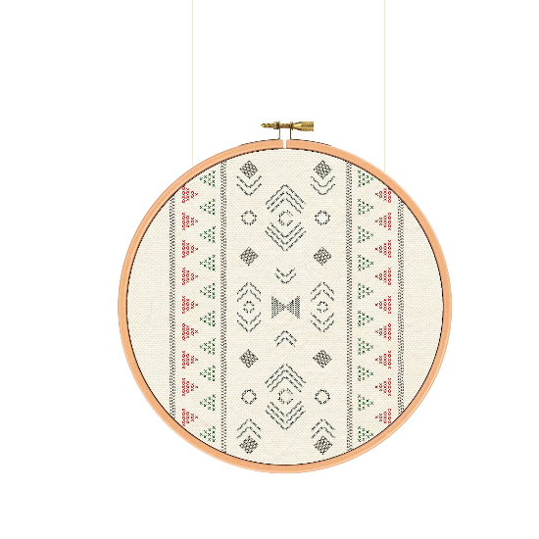 | “Infinite Stitches: Weaving a Dance between Tradition and Trend"  M7 - The Cutting Studio | 24 February – 30 March 2024  The installation curated by Qatari fashion designer Ghada Al Subaey under her latest initiative The Cutting Studio seamlessly blends Qatari heritage motifs and Palestinian embroideries in a contemporary light. Hung on minimalist wooden frames, the embroidered works create an elegant fusion of tradition and modernity.
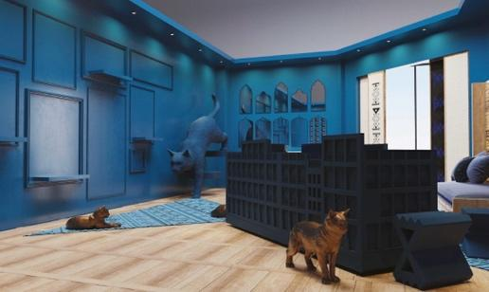 | “Embrace Blue”  Sahat Al Nakheel, Msheireb Downtown Doha | 24 February – 30 March 2024  Artist and designer Bachir Mohamad (Syria), in collaboration with Ahmad Al Emadi (Qatar) and Micheal Ghanem (Lebanon) showcase this exclusive collection for Bluribbon Design Atelier. The collection aims to seamlessly blend traditional Qatari architecture with a modern contemporary twist in the realm of furniture and furnishings. The collection draws inspiration from the rich cultural heritage of Qatar, particularly emphasising the intricate details found in local architecture.
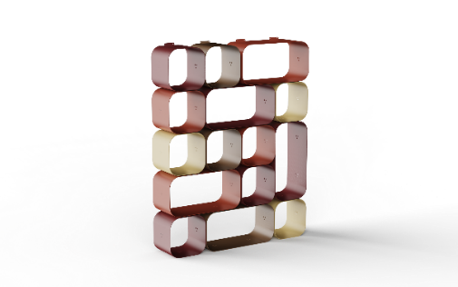 | Msheireb to Milan  FROMM. Studio, M7 | 24 February – 8 March 2024  FROMM., a design platform and company launched between Qatar and Italy to create the ideal fusion of Design and Manufacturing are showcasing three unique collections. The Shurouq Collection, named after the Arabic word that translates to “Dawn”, embodies not only part of the inspiration behind the designs of this collection, but the dawn of the company itself. The collection features the Haima’ Armchair by Maryam Al Suwaidi (Qatar); Maiz Coffee Table and Multicolour Maktaba Wall Unit by Shua’a Ali (Qatar); and Shurouq Dining Table Set by Kaltham Al Kuwari & Aisha Al Mohannadi (Qatar). The Ottoman Dream Collection, a celebration of 500 years of Ottoman heritage and luxury, features Pavo Sofa by Antonio Aricò (Italy), and Minara Lamp and Vase by Abdulrahman Al Muftah (Qatar). FROMM. are also showcasing The Wanas Collection by Noora Al Melhim, a blend of tradition and modernity.
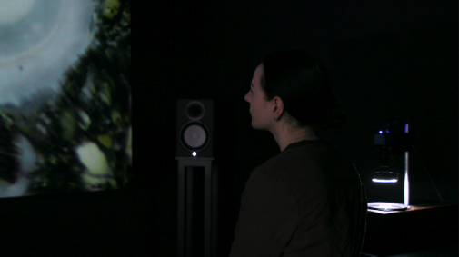 | "The World As We Know It Is Changing"  Galleria, Msheireb Downtown Doha | 24 February – 28 February 2024  Created by French artist Guillaume Rouseré during his residency at Fire Station: Artist in Residence in 2018-2019 and shown at Mathaf: Arab Museum of Modern Art in 2022, the installation invites visitors to listen to recordings from various ecosystems while watching images projected by a Cymascope, which visualises sound through water vibrations. The recordings include sounds from forests, deserts, rivers, and human activities, along with memories about fresh water in different languages. The artwork prompts reflection on human impact on the planet and access to clean water, inviting emotional questioning and self-reflection as it disconnects the audience from their surroundings.
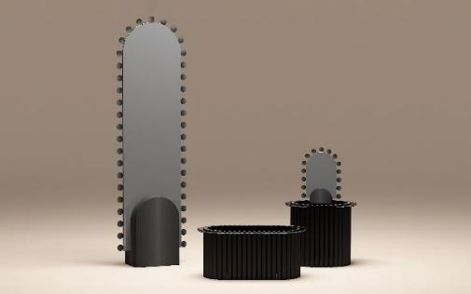 | “Cultural Kinship”  M7, Studio 7 | 24 February – 30 March 2024  Curated by Joe Bou Abboud, founder of Boo Design Studio, and Asma Derouiche, creative director at Studio 7 Qatar, the exhibition are showcasing the richness of the Middle Eastern and Arab identity through innovative design products. “Cultural Kinship” establishes a dialogue between traditional and contemporary design practices, highlighting the evolving nature of cultural identity. Participating creators include Wael Morcos, Maryam Al-Homaid, Marco Bruno, Giovanni Innella, Yasmeen Suleiman, House of Today, Abdulrahman Muftah, Thomas Modeen, Asma El-Derouiche, Boo design studio, The Project, Sizar Alexis Azza Dsouli, Archivart X Akacha, and Majdulin Nasrallah.
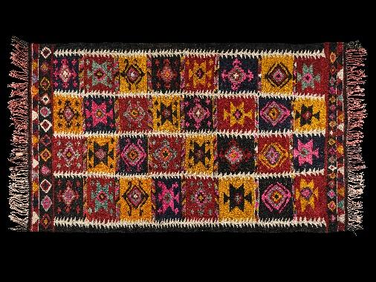 | “Crafting Uzbekistan: Tradition in Threads”  M7, Learning Space | 24 February – 30 March 2024  Presented by the Uzbekistan Art and Culture Development Foundation integrates the rich history of Uzbek craft tradition with contemporary creativity. The immersive showcase opens by providing a focus on wood and textile craft with a selection of historical and contemporary artefacts including handwoven silk ikat and Bakhmal fabrics showcased in parallel with rich carved wooden traditional objects. The scenography stands as an atmospheric experience rooted from the traditional crafts of Uzbekistan. It uses ‘optical weaving’ (with 31,000 lenticular tiles with 26,000,000 threads in total) as a conceptual logic to drive the aesthetic and spatial qualities of the space, with an emphasis on colour and triggering the senses. The exhibition features 50 craft pieces, including a new creation for Design Doha from Lebanese designer Nada Debs who will unveil her new creation produced together with the Uzbek wood master Sirojiddin Rahmatillaev that offers a modern interpretation of a traditional and iconic furniture element.
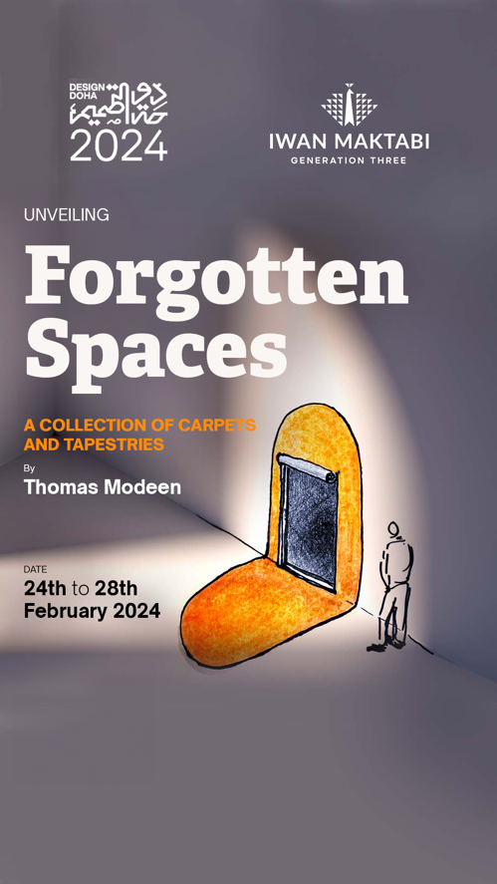 | “Forgotten Spaces: An Immersive Installation of Carpets and Tapestries”  Galleria, Msheireb Downtown Doha | 24 February – 30 March 2024  The exhibition comprises a set of carpets and tapestries designed for areas that are overlooked, or which remain difficult to furnish, and interior spaces that are often ignored, or forgotten. Here the designs occupy simultaneously both horizontal and vertical spaces, volumes in the corners of rooms, and the areas surrounding doorways. They perform as small architectural compositions, with their own spatial, acoustic, tactile, even olfactory qualities. The designs aim not only to acknowledge but celebrate these omitted locations and provide them with their own distinct gravitas and presence.
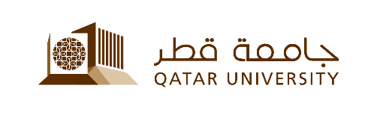 | “Virtual Visions and DAUP” - Interactive Installation by Qatar University  Sahat Al Nakheel, Msheireb Downtown Doha | 24 February – 29 February 2024  Virtual Visions - This installation integrates public participation and exploration in both VR and non VR platforms. The installation is an extension of Mohammed's research which explores the utilization of VR as a design tool in architectural design, The proposal aims to enable accessible design through the use of VR as a design tool to the public, allowing them to spend 10 - 20 minutes sketching/designing in 3D space. The second interactive section is a video-game based PC setup with a controller that allows users to explore the structures designed by the VR participants all compiled into a single digital world. The overall intention of this installation focuses on public involvement to build and explore a virtual world  DAUP - The space will be organized to host mainly the work done from the students in their different years of the school. A path into the panels’ exhibition for printed works including concept and detailed drawings of their work, some moquettes and video for digital representation. An area will be hosted for a public use for conferences, with our upcoming Architecture Day, which will feature an exhibition of students' work, discussions, a department timeline overview, and the announcement of the Ashgale competition. On live studio will be done during the days to understand the real lesson in the architectural university.
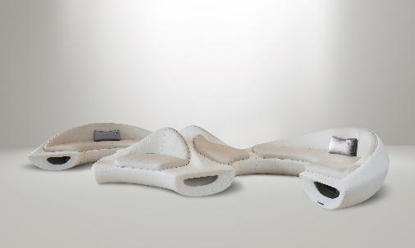 | Jalset Sawa Booth by Studio EF  M7 – 1st Floor | 24 February – 30 March 2024  A marvel of 3D printing, Jalset Sawa echoes the undulating sand dunes of Doha, seamlessly blending design with the landscape. Crafted from recycled plastic, its organic form conceals an ingeniously integrated seating structure, maintaining a continuous, unbroken aesthetic resulting in a sculptural piece that is functional. The challenge of merging industrial materiality with fine dining elegance is triumphantly met through its sculptural, futuristic shape, and the luxurious touch of cushioned leather upholstery.
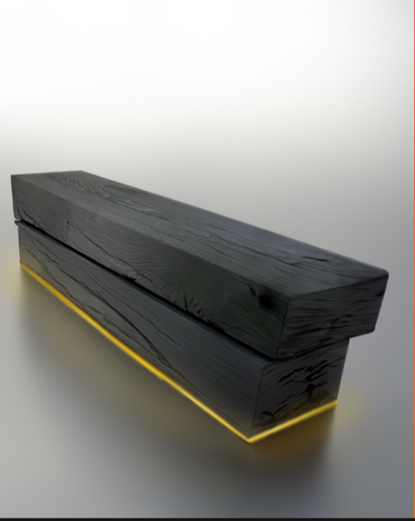 | “Momental Contemplation”  Msheireb Company House | 24 February – 30 March 2024  Juliano Wahab and Serine El Batal have designed a bench made from repurposed Brazilian Massaranduba wood, salvaged from Brazil’s train tracks. This elemental feature, strategically placed in this landscape, beckons passersby to a momentary halt. The large, charred pieces of wood serve as a symbolic manifestation of introspection, and as a metaphorical wheel stopper. Its presence urges individuals to pause, inviting them to consider the velocity of their lives. The subtle light emanating from beneath the bench adds a duality to life's fleeting nature, simultaneously alluding to the enlightening power of reflection. The installation will be on view at Msheireb Company House, a location chosen to honour Qatari pioneers who laid the foundations for the nation.
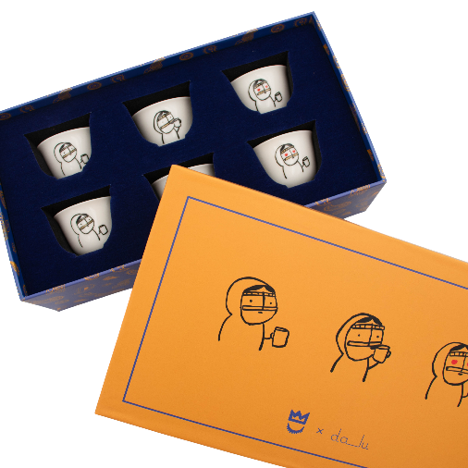 | “Dalu: The Home of Artistic Collaborations”  Galleria, Msheireb Downtown Doha | 24 February – 30 March 2024  This exhibition seeks to showcase the talent of local artists and artisans. Dalu products are not just items; they are stories and pieces of art designed to cultivate conversations and contribute to a cultural narrative that transcends boundaries. Each piece illustrates a snapshot of the artist's connection and cultural exchange with Qatar and its rich heritage.
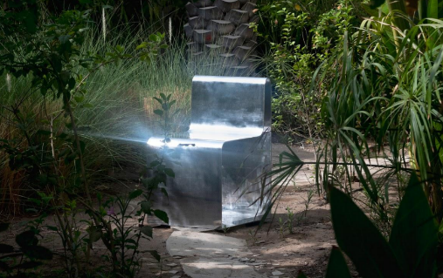 | “BARIID” by Altqadum  Sahat Al Wadi, Msheireb Downtown Doha | 24 February – 30 March 2024  Altqadum is a design studio with expertise in architecture and interior design, providing creative direction in designing spaces, objects, and experiences. They present their responsive chair design, formed with a single aluminium sheet. The thinly folder silhouette design is intended to adapt to its environment, reflecting both the space and its temperature.
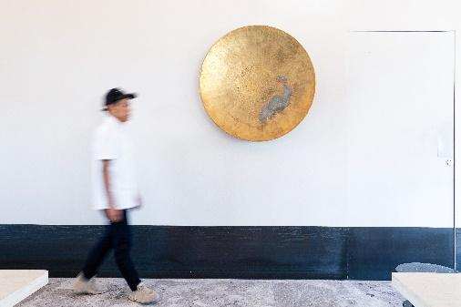 | Kuwait Design Hub: An Eco-Cultural Tapestry  Galleria, Msheireb Downtown Doha | 24 February – 28 Februray 2024  Khaleejesque are presenting Kuwait Design Hub, a showcase of 6 Kuwait-based designers and their artworks at the Design Doha. Kuwait Design Hub is a dynamic showcase of innovative works by Kuwait-based designers who intricately weave sustainable practices with the rich tapestry of contemporary Arab identity, creating a unique platform that highlights the fusion of environmental consciousness and cultural heritage in modern design. The exhibition aims to be a tapestry of ecological consciousness and artistic expression, highlighting how traditional values and contemporary design practices can coexist harmoniously. It seeks to inspire visitors by demonstrating how sustainability is not just an environmental necessity but also a driver of creative brilliance.
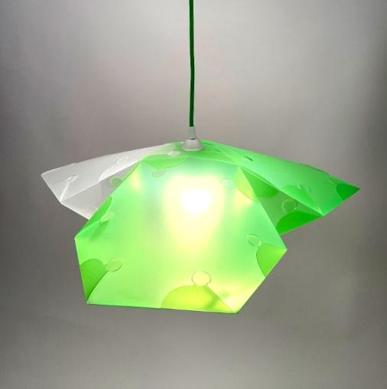 | Bunch of Mottos  Galleria, Msheireb Downtown Doha | 24 February – 30 March 2024  Bunch of Mottos by MotoElastico and Alaa Albarazy is an interactive light installation that takes advantage of the flexibility of M-otto, a modular plastic system that can be utilized to create complex forms without using any connecting device. A series of lights with different shapes will hang from the ceiling and will respond to the presence of the audience in two different ways. The first interaction will be through technology: the bunch will respond to the presence of the visitors through sensors that will alter the behaviour of the lights. The second interaction will be through collaboration. A part of the installation will be fully customizable: during a series of small workshops the audience will be invited to design new elements that will be included in the installation.
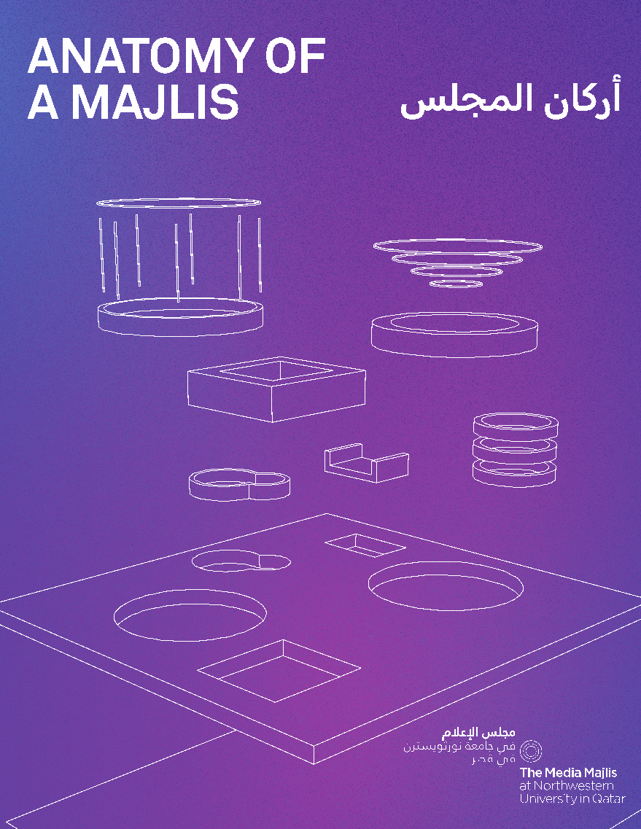 | Anatomy of a Majlis  Galleria, Msheireb Downtown Doha | 24 February – 9 March 2024  The Media Majilis at Northwestern University in Qatar has partnered with several local and regional organisations to bring an exciting and engaging activation to the heart of Msheireb during the inaugural Design Doha in 2024. The concept of a majlis is ubiquitous within the Arab world. Over time, this construct of communication has evolved and become more than just a physical space. The installation is inspired by the traditions of the Arabic majlis but incorporates difference areas adapted to difference functions. Throughout the 4-day event it will be activated with a café, gaming station, and a photography studio.
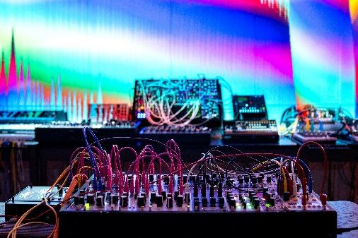 | Sonic Fields  Liwan Design Studios and Labs | 24 February – 30 March 2024  This installation is a Sonic Fields project designed and developed by Michale Hersrud, Simone Muscolino, and Kate Sicchio. The project aims to blend a generative soundscape with code-crafted visuals, creating an immersive sensory experience. "Sonic Jeel" is imagined as a captivating environment where sound and vision interweave to create a unique Majlis to relax and wonder. The core of this installation is an evolving soundscape crafted from a rich library of local field recordings, supplemented by electronic melodies, blips, and glitches. This audio experience will be paired with projected visuals transforming the space into an experience of sight and sound.
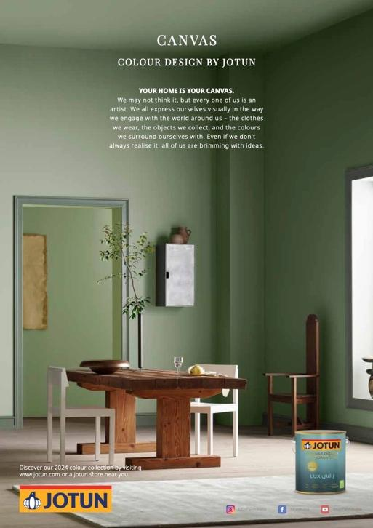 | Jotun Space  Galleria, Msheireb Downtown Doha | 24 February – 30 March 2024  From our clothes to our homes, the colours that we surround ourselves with are a reflection of who we are and how we want to feel. In tribute to the art and science of colour, Jotun presents 23 colours for 2024.
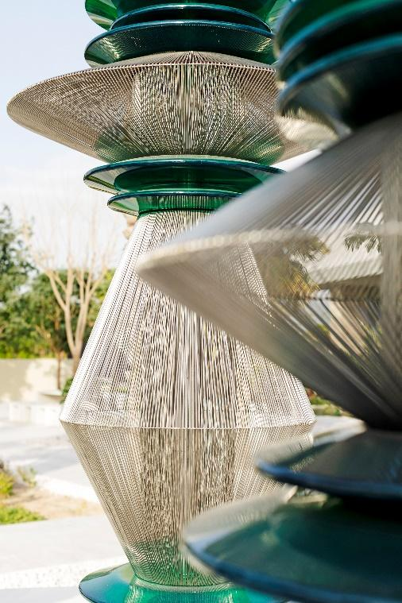 | Ripples Of Hope by Asma Derouiche  M7, Studio7  A lone pebble initiates a cascade of waves in a tranquil pond, echoing the extensive reach of life's little moments. "Ripples of Hope," by Asma Derouiche, fuses resilient metal with fragile glass, reflecting strength amidst vulnerability. This art contemplates the fleeting nature of experiences against eternity's backdrop, serving as a metaphor for the poignancy of life’s inevitable coexistence with death. Illuminated ripples symbolize the enduring impact of small, meaningful acts, while the adaptable design mirrors our ever-fading memories. Derouiche's work celebrates resilience, infinity, and art's transformative role in our transient existence, highlighting the perpetual influence of the Ripple Effect on our shared lives, loves and losses. These structures speak of the resilience and the infinite cycle of life and art in our ephemeral world, capturing the essence of hope and remembrance in the wake of loss.

For more information, visit https://designdoha.org.qa/en/ or follow @designdohabiennial on Instagram.

-ENDS-

About Qatar Museums
Qatar Museums (QM), the nation's preeminent institution for art and culture, provides authentic and inspiring cultural experiences through a growing network of museums, heritage sites, festivals, public art installations, and programmes. QM preserves, restores, and expands the nation's cultural offerings and historical sites, sharing art and culture from Qatar, the Middle East, North Africa, and South Asia (MENASA) region with the world and enriching the lives of citizens, residents, and visitors.

Under the patronage of His Highness the Amir, Sheikh Tamim bin Hamad Al Thani, and led by its Chairperson, Her Excellency Sheikha Al Mayassa bint Hamad bin Khalifa Al Thani, QM has made Qatar a vibrant centre for the arts, culture, and education in the Middle East and beyond. QM is integral to the goal of developing an innovative, diverse, and progressive nation, bringing people together to ignite new thinking, spark critical cultural conversations, educate and encourage environmental stewardship and sustainable practices, and amplify the voices of Qatar's people. Since its founding in 2005, QM has overseen the Museum of Islamic Art and MIA Park, Mathaf: Arab Museum of Modern Art, the National Museum of Qatar, QM Gallery Al Riwaq, QM Gallery Katara and the 3-2-1 Qatar Olympic and Sports Museum. Future museums include Dadu, Children's Museum of Qatar, Qatar Auto Museum, Art Mill Museum and the Lusail Museum.

Through its newly created Creative Hub, QM also initiates and supports projects—such as the Fire Station Artist in Residence, the Tasweer Qatar Photo Festival and the creative hub for innovation, fashion and design M7—that nurture artistic talent and create opportunities to build a strong and sustainable cultural infrastructure.

Animating everything that Qatar Museums does is an authentic connection to Qatar and its heritage, a steadfast commitment to inclusivity and accessibility, and a belief in creating value through invention.

About Qatar Creates
Qatar Creates curates, celebrates, and promotes cultural activities within Qatar. Working with partners in museums, film, fashion, hospitality, cultural heritage, performing arts, and the private sector in Qatar, the Qatar Creates platform amplifies the voice of Qatar’s creative industries, directly connecting audiences to events.

About Msheireb Properties
A national real estate development company and a subsidiary of Qatar Foundation established as a commercial venture to support the foundation in achieving the Qatar National Vision 2030. The company aims to enrich people’s lives and improve the overall quality of how they live, work and thrive by creating modern, innovative, and authentic developments.

Msheireb Properties partnered with industry leaders and experts in order to align the architectural lessons of the past with the latest in eco-friendly technologies, in order to employ a new approach to urban planning; one that combines traditional methods and modern technology to preserve the environment as well as the cultural identity of Qatar.

An emerging leader in sustainable development, Msheireb Properties’ new language is used to create buildings of a shared DNA, reviving local heritage and culture through a unified architectural idiom.

Its signature city district, Msheireb Downtown Doha, is developing a blueprint for sustainable urban regeneration.
Msheireb Properties received ISO certification from the British Standards Institution for quality (ISO 9001:2015), environmental performance (ISO 14001:2015), occupational health and safety (BS OHSAS 18001:2007), and Risk Management Standard (ISO 31000:2009).
About FROMM.:
FROMM., launched between Msheireb and Milan, is a luxury contemporary furniture brand creating the ideal fusion of design and manufacturing. Born with the vision of empowering young talents in the region, FROMM. debuted at Milan Design Week in 2022, showcasing its inaugural Shurouq collection. We collaborate with both local and international designers, producing collections that masterfully blend heritage innovation with contemporary aesthetics. Our educational platform, FROMM.LAB, offers designers the opportunity to co-design, collaborate, and contribute to FROMM.'s collections. These collections are represented both locally and globally, making appearances at some of the industry's most significant events. At FROMM., we believe in design's power to transcend borders and celebrate the rich tapestry of cultural exchange.

