Qatar Museums’ 3-2-1 Qatar Olympic and Sports Museum and Seashore Group Signs Collaboration Agreement for ‘Obstacle Course Challenge’ at Doha Expo 2023
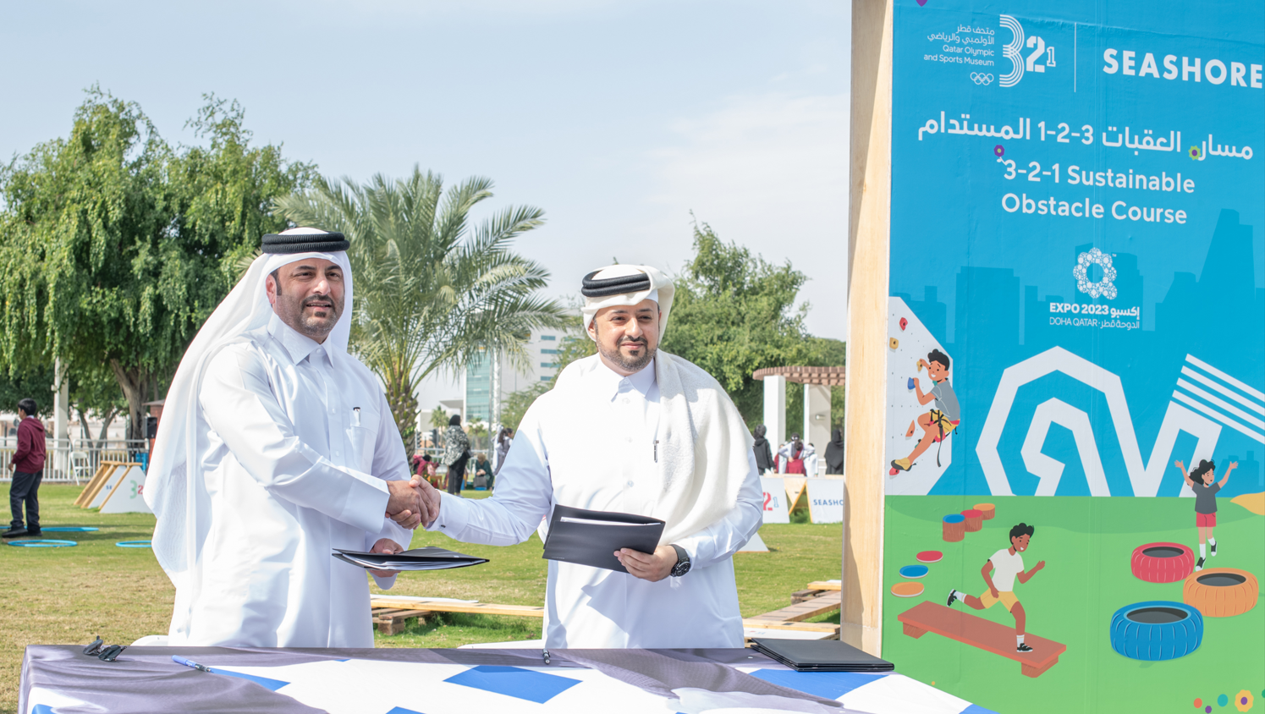

Doha, February 14, 2024 — Qatar Museums’ 3-2-1 Qatar Olympic and Sports Museum and Seashore Group participated in an official signing ceremony that highlighted a collaboration agreement between both the respective entities for ‘The 3-2-1 Sustainable Obstacle Course Challenge, at the Doha Expo 2023. The signing ceremony took place between Mr. Mohammed Saad Al Rumaihi, Chief Executive Officer at Qatar Museums and Mr. Saqer Saeed Al Mohannadi, Vice Chairman of the Board of Directors, Seashore Group at the Cultural Zone at Doha Expo 2023.

‘The 3-2-1 Sustainable Obstacle Course Challenge’ aimed to provide the perfect family bonding experience at the 3-2-1 Obstacle Course, as families geared up to advance their running, climbing, jumping, crawling, and balancing skills over the course of 16 obstacles. The course was designed to test all ages, abilities, and fitness levels with the help of endurance and strength obstacles.

Mr. Saqer Saeed Al-Mohannadi, Vice Chairman of the Board at the Seashore Group, expressed his pleasure at collaborating with the Qatar Olympic and Sports Museum 3-2-1, highlighting the positive impact on both parties and the community. He said: "This collaboration will enhance environmental sustainability and sports awareness among community members as we continue to highlight the significance of these aspects in the country's strategy for building the future. The global interest in these issues prompts us to focus on educational, informative, and sports-related aspects to promote a culture of sustainability and environmental conservation."

QOSM continues to demonstrate its commitment towards the environment having used an eco-friendly approach for its Sustainable Obstacle Course Challenge where the obstacles used were made of biodegradable, and recyclable materials. The 3-2-1 Sustainable Obstacle Course Challenge featured a range of challenging obstacles that tested the participants' strength, speed, agility, motor skills, coordination, and endurance, thereby promoting physical activity and a healthier lifestyle, encouraging the community to stay active and fit.

The Seashore Group has a long-standing legacy of providing innovative and sustainable industrial solutions, and the group is dedicated to enhancing the environment by undertaking various environmental projects in Qatar, aligning with the National Vision 2030.

-END-

About 3-2-1 Qatar Olympic and Sports Museum

The 3-2-1 Qatar Olympic and Sports Museum is Qatar's museum of sports history, offering an unforgettable and inspiring interactive journey through the history and legacy of sports and the Olympic Games. The museum delivers a multi-layered educational narrative that combines a comprehensive collection with state-of-the-art technology and documents the significance of sports in Qatar. One of the largest Olympic Museums in the world, 3-2-1 houses hundreds of objects from around the globe, from the origins of sports to the modern day. Through its participatory spaces and planned programming, the museum aims to inspire and engage its community and encourage the public to participate in sports and physical activity. The museum is located at Khalifa International Stadium, part of Qatar's Aspire Zone Foundation. The Khalifa International Stadium, originally built in 1976, is one of the sites used to host the FIFA World Cup Qatar 2022™. Abdulla Yousuf Al Mulla has served as the Director of 3-2-1 Qatar Olympic and Sports Museum since 2019.

About Qatar Museums
Qatar Museums (QM), the nation's preeminent institution for art and culture, provides authentic and inspiring cultural experiences through a growing network of museums, heritage sites, festivals, public art installations, and programmes. QM preserves, restores, and expands the nation's cultural offerings and historical sites, sharing art and culture from Qatar, the Middle East, North Africa, and South Asia (MENASA) region with the world and enriching the lives of citizens, residents, and visitors.
Under the patronage of His Highness the Amir, Sheikh Tamim bin Hamad Al Thani, and led by its Chairperson, Her Excellency Sheikha Al Mayassa bint Hamad bin Khalifa Al Thani, QM has made Qatar a vibrant centre for the arts, culture, and education in the Middle East and beyond. QM is integral to the goal of developing an innovative, diverse, and progressive nation, bringing people together to ignite new thinking, spark critical cultural conversations, educate, and encourage environmental stewardship and sustainable practices, and amplify the voices of Qatar's people. Since its founding in 2005, QM has overseen the Museum of Islamic Art and MIA Park, Mathaf: Arab Museum of Modern Art, the National Museum of Qatar, QM Gallery Al Riwaq, QM Gallery Katara and the 3-2-1 Qatar Olympic and Sports Museum. Future museums include Dadu, Children's Museum of Qatar, Qatar Auto Museum, Art Mill Museum, and the Lusail Museum.
Through its newly created Creative Hub, QM also initiates and supports projects—such as the Fire Station Artist in Residence, the Tasweer Qatar Photo Festival, the creative hub for innovation, fashion, and design M7, and Liwan Design Studios and Labs —that nurture artistic talent and create opportunities to build a strong and sustainable cultural infrastructure.
Animating everything that Qatar Museums does is an authentic connection to Qatar and its heritage, a steadfast commitment to inclusivity and accessibility, and a belief in creating value through invention.

About Seashore Group
The Seashore Group, with its diverse activities and aspirations for leadership and excellence, is dedicated to building an advanced and sustainable society in line with Qatar's National Vision 2030. It places a strong emphasis on social responsibility and has invested in purposeful initiatives that have contributed to community development.
The Seashore Group takes pride in promoting social responsibility through various programs and initiatives, supporting the younger generations through workshops and competitions, and sponsoring numerous local and international sports tournaments. Additionally, it has participated in and sponsored many regional summits and conferences. The group has also activated internal partnerships with state institutions to ensure the achievement of its societal goals.
Recognizing the importance of preserving heritage as a national memory and a fundamental pillar of Qatari identity, collaboration with Qatar's museums is pursued in various aspects. All of these efforts are part of the work towards realizing Qatar Vision 2030 and turning it into tangible reality.
FIND US ONLINE:
Qatar Museums
Twitter: @Qatar_Museums | Instagram: @Qatar_Museums | Facebook: @QatarMuseums
3-2-1 Qatar Olympic & Sports Museum
Instagram: @321qosm | Twitter: @321QOSM | Facebook: 3-2-1 Qatar Olympic and Sport Museum
http://www.321.qa/
MEDIA CONTACTS:
Hanan Saif, Qatar Museums: h.saif@qm.org.qa (+974 4402 8543)
Alli Steinberg, Polskin Arts: alli.steinberg@finnpartners.com (+1 212 583 2754)

