PR# 36: 04 December 2022
Doha - Qatar

Her Excellency Sheikha Al-Mayassa Inaugurates
Qatar-TotalEnergies Playground at the National Museum of Qatar

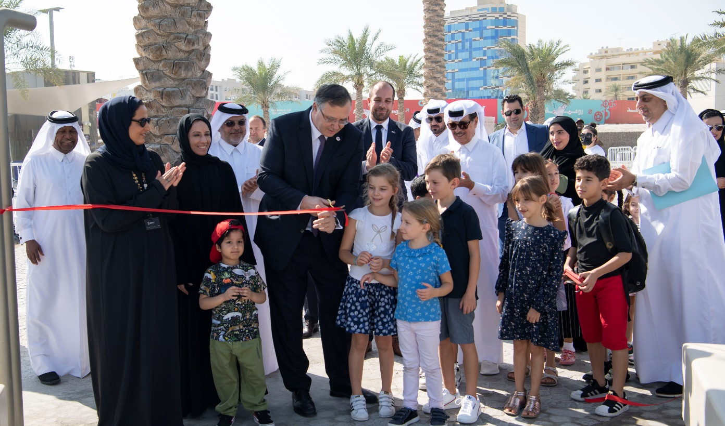

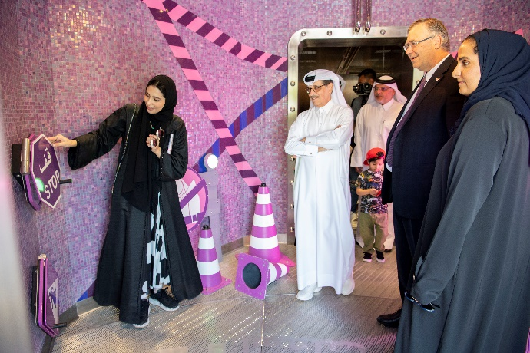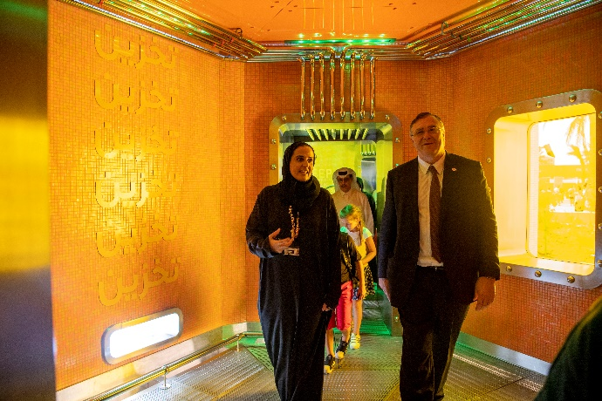
The Qatar-TotalEnergies Playground, located in the outdoor National Museum of Qatar (NMoQ) was inaugurated on December 4 by Her Excellency Sheikha Al-Mayassa bint Hamad bin Khalifa Al Thani, Chairperson of Qatar Museums and Patrick Pouyanné, Chairman of the Board and Chief Executive Officer at TotalEnergies. It will provide a unique experience for families to explore and discover the story of energy in Qatar through meaningful play.
The playground is part of the partnership between TotalEnergies and Qatar Museums and was designed by Taylor Cullity Lethlean (TCL) with the construction work carried out by Ashghal.
It is designed to provide a fully immersive and educational experience in which visitors of all ages can learn about the various energies deployed in Qatar from the oil, gas and liquefied natural gas to the renewable energies and electricity. Sustainability is also addressed through topics such as carbon capture, recycling of polymers and road safety.
Her Excellency Sheikha Al Mayassa bint Hamad bin Khalifa Al Thani, Chairperson of Qatar Museums, said: “Qatar Museums has always been a key player in promoting education through creativity and play. In a playful ecosystem children learn through play making knowledge accessible through experience to all age groups and backgrounds. This is one of many playgrounds that we have developed across the country, and hope our communities and visitors enjoy them by connecting with family, friends, nature and being outdoors. We are grateful for our partnership with TotalEnergies, where we can engage with the wider community and visitors to showcase Qatar’s rich heritage and by default enhancing the quality of our lives.”

“TotalEnergies is thrilled about its partnership with Qatar Museums and in particular about this unique project dedicated to our children, which harmoniously combines education and entertainment in such an iconic environment. Together with culture, energy is an important part of Qatar’s history; and this family-friendly playground is a successful connection between culture and energy” , said Patrick Pouyanné, Chairman of the Board and Chief Executive Officer at TotalEnergies. He continued by saying “TotalEnergies was enthusiastic to support Qatar Museums in the concept definition and the execution of this multi-energy playground that also included green electricity and energy efficiency studies aiming at reducing its carbon footprint.”
The playground’s maze-like architecture includes 15 interactive playing pods, one per energy and a series of crawl tunnels in the form of oversized ‘pipes’ for children form pathways. The playground also contains a water play area and aims to create a sustainable outdoor environment that is stimulated by human energy. Other features include dry mist fans arranged to provide more comfortable microclimates throughout the pods.
Finally, the playground’s design is sustainable as it is partially powered by green electricity from nearby installed solar panels.
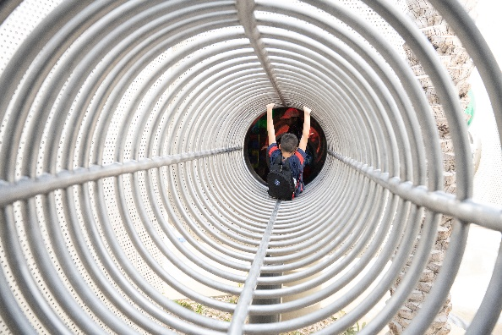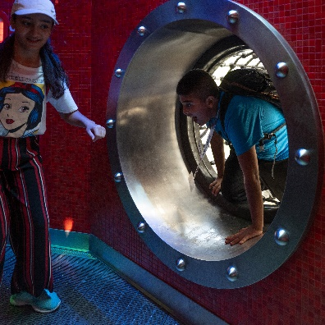
***
About TotalEnergies in Qatar

In Qatar, TotalEnergies has been present since 1936, and is active in exploration and production, refining and petrochemicals, and marketing of lubricants, and renewable energies. TotalEnergies is the shareholder and sole operator of Al Khalij offshore oilfield, and a shareholder in North Oil Company, the operator of Al Shaheen offshore oilfield.

TotalEnergies is also one of the founding partners of Qatargas and Dolphin Energy and holds a 16.7% and 24.5% interest in Qatargas 2 and Dolphin Energy respectively. The Company is also present in five downstream joint ventures : QAPCO, Qatofin, RLOC and Laffan Refineries 1 & 2.

In 2022, TotalEnergies was awarded a 6.25% interest in the 32 million tons per annum (Mtpa) NFE project; followed by a 9.375% participating interest in the 16 Mtpa North Field South (NFS) LNG project. It is also a partner in the Al Kharsaah Solar PV IPP Project, a 800 megawatt-peak (MWp) solar plant.

@TotalEnergiesQA TotalEnergiesQatar TotalEnergies_QA

About National Museum of Qatar

The National Museum of Qatar (NMoQ) seeks to preserve and celebrate Qatar’s heritage and natural history, engage with its present, and inspire the country’s ambitions for the future. The museum, which opened in March 2019, gives voice to the country’s heritage and culture through commissioned films and artworks, storytelling, artefacts, and music, combining wide-ranging scholarship with oral histories of the people of Qatar. NMoQ is organised as a thematic and chronological sequence of galleries, which take the visitor on a 1.5-km journey through immersive, multisensory experiences that provide multiple perspectives. The iconic building, designed by Pritzker Prize-winning architect Jean Nouvel, is based on the form of the desert rose and is composed of large interlocking disks of different diameters and curvatures that surround the restored historic Palace of Sheikh Abdullah bin Jassim Al Thani (1880-1957), son of the founder of modern Qatar. Sheikha Amna bint Abdulaziz bin Jassim Al-Thani has served as director of the museum since 2013.

