WORLD PREMIERE OF THE DESERT ROSE SYMPHONY TO TAKE PLACE
30 OCTOBER, PERFORMED BY THE QATAR PHILHARMONIC ORCHESTRA AT THE NATIONAL MUSEUM OF QATAR

Commemorative symphony by Syrian American composer and pianist
Malek Jandali was commissioned by Qatar Museums’ Years of Culture
Jandali is named honorary Composer-in-Residence of Qatar Museums
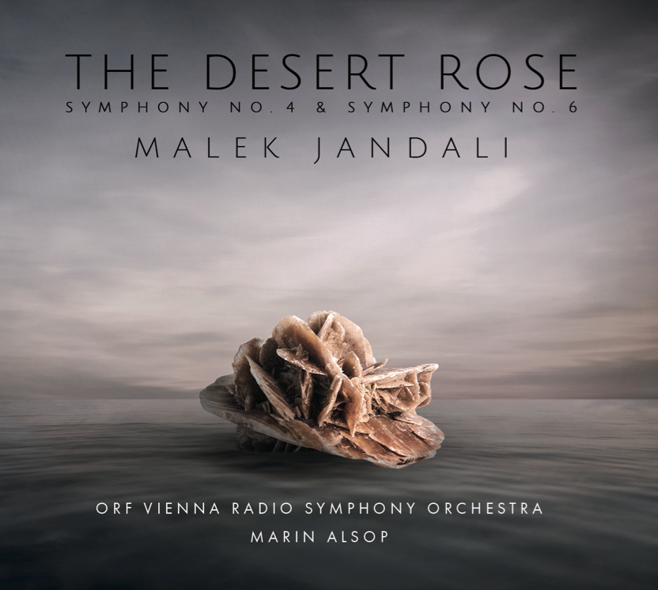

Doha, Qatar, 20 October, 2022 — the Qatar-MENASA 2022 Year of Culture today announced the world premiere of The Desert Rose symphony will take place on 30 October 2022 as part of the 10 year anniversary celebration of the Years of Culture program. The commemorative symphony, commissioned by the Years of Culture, will be performed by the Qatar Philharmonic Orchestra with Grammy-nominated guest conductor Alastair Willis, on the Baraha of the National Museum of Qatar. The symphony, which celebrates Qatar’s culture and heritage, is composed by Malek Jandali, a prominent Syrian American composer and pianist and Qatar Museum’s new honorary Composer-in-Residence. A public performance will be held on 31 October 2022 in the same location. Tickets for the performance are available HERE. The two concerts are part of Qatar Creates — the year-round national cultural movement that curates, promotes, and celebrates the diversity of cultural activities in Qatar; connecting resident and global audiences with Qatar’s creative industries.

The Desert Rose album features two world-class symphonies, including Symphony No. 6 The Desert Rose and Symphony No. 4 for String Orchestra recorded under the helm of distinguished American conductor Marin Alsop with the ORF Vienna Radio Symphony Orchestra. It is now available on music streaming services and copies of the album are at all Qatar Museums gift shops.

The Desert Rose is inspired by nature’s desert rose, which form over millennia through the interaction of minerals, sand, and water in regions such as Qatar—a land of desert and sea. This wonder of nature is also the basis for Jean Nouvel’s spectacular design of the National Museum of Qatar (NMoQ), a stunning structure of interlocking discs that tells the story of Qatar from the natural history of its origins through its cultural developments to the cutting-edge technologies and international allure of today. The Desert Rose symphony takes its inspiration from both “desert roses,” transforming them into a consummate orchestral work that preserves and extends the rich heritage of the region. The symphony is also a reference to the flag of Qatar, with its nine-movements—each based on an iconic element of Qatari culture—evoking the nine-point serrated line on the flag.

The symphony is the culmination of more than four years of research and exploration, during which Jandali entrenched himself in the sounds and landscapes of Qatar, to preserve and present Qatari cultural heritage and traditions on the global stage.

Director of Cultural Diplomacy Aisha Al Attiya said, “I take great pleasure in announcing these symphonies, which so beautifully tell the story of Qatar’s history and culture through music. Malek Jandali has a sincere appreciation of Qatari heritage, and his mission to unite nations across the world through the arts aligns so strongly with the purpose of Years of Culture. We are delighted to be collaborating with him on these inspiring symphonies.”

“Through this timely partnership with Years of Culture, I have the honor of presenting Qatar’s musical traditions on the global stage,” states Malek Jandali. “Together, we are contributing our rich Arab heritage to the lexicon of classical music and the progression of cultural modernity. We welcome orchestras around the world to join our symphony of peace, unity, and humanity.”

Like its inspirations, The Desert Rose symphony harbors an elaborate interlocking structure. Bookmarked in A-flat major, in which key the first and last movements end, the Symphony comprises three interlaced musical forms. One is a Qatari symphonic suite based on traditional folk music and dances using the principal of contrast: Movements II, III, V and VII. Second is a traditional “old-fashioned” symphony of four Movements I, IV, VI and IX. The third combines the first two “symphonies” with Movement VIII, which brings about the grandiose conclusion of The Desert Rose.

Conductor Marin Alsop said, “I don’t know of another composer who so successfully weaves in the Arabic, particularly the folk [musical] elements. Jandali belongs among the superb composer poets of our time. A meaningful voice of quite astonishing, almost unearthly beauty.” As to nature’s desert rose, an example of which she was able to touch leading up to the recording sessions, Alsop said she was struck by its sturdiness. “Seeing the actual desert rose made me feel much more connected to our heritage as human beings on the planet. And maybe that’s the goal—to find that fundamental connection among all of us as human beings instead of all these superficial things.”

The album’s second symphony, Symphony No. 4 for String Orchestra, was composed by Jandali in 2020 and inspired by the idea of writing for strings only while continuing his quest to preserve and present the rich heritage of Arab music. “I was especially interested in trying to obtain all the colors of the orchestra using a palette of instruments that on the surface seem to present a similar timbre,” explained Jandali.

###

About Malek Jandali
Described as “deeply enigmatic” (Gramophone) and rich with “heart-rending melodies, lush orchestration, clever transitions and creative textures” (American Record Guide), Malek Jandali’s music is widely regarded as “a major new addition to the 21st century’s symphonic literature” (Fanfare magazine). Jandali’s symphonic works not only integrate Middle-Eastern modes into Western classical forms and harmony but also echo UNESCO’s call to preserve and protect the rich cultural heritage of his homeland Syria at a time when it is being eradicated. Jandali’s music have been performed and commissioned by numerous symphony orchestras such as the Royal Philharmonic Orchestra, Baltimore Symphony Orchestra, Zagreb Philharmonic Orchestra, ORF Vienna Radio Symphony Orchestra, and the Russian Philharmonic Orchestra.

Also an “acclaimed pianist” (BBC World News) noted for his passion, imagination, and authenticity, Mr. Jandali enjoys a remarkable career that has taken him around the globe. He continues to captivate audiences in performances at such prestigious venues as Carnegie Hall, the Kennedy Center, Wiener Konzerthaus, Madrid’s National Auditorium, Cadogon Hall, Stockholm Konserthuset, Cairo Opera House, Sydney Opera House, and the United Nations Headquarters. Jandali is the recipient of the 2014 Global Music Humanitarian Award and in 2015, the Carnegie Corporation of New York honored him as a Great Immigrant. Mr. Jandali is the composer-in-residence at Queens University of Charlotte and Qatar Museums. He is passionate about making the arts accessible to all and is the founder and CEO of Pianos for Peace, a non-profit organization dedicated to building peace through music and education.

About Marin Alsop
One of the foremost conductors of our time, Marin Alsop represents a powerful and inspiring voice. Convinced that music has the power to change lives, she is internationally recognized for her innovative approach to programming and audience development, deep commitment to education, and advocacy for music’s importance in the world. The first woman to serve as the head of a major orchestra in the United States, South America, Austria and Britain, she is, as the New York Times put it, not only “a formidable musician and a powerful communicator” but also “a conductor with a vision.” The first and only conductor to receive a MacArthur Fellowship, Alsop has also been honored with the World Economic Forum’s Crystal Award, and made history as the first female conductor of the BBC’s Last Night of the Proms. Amongst many other awards and academic positions, she serves as 2020 Artist-in-Residence at Vienna’s University of Music and Performing Arts, is Director of Graduate Conducting at the Johns Hopkins University’s Peabody Institute and holds Honorary Doctorates from Yale University and the Juilliard School. To promote and nurture the careers of her fellow female conductors, in 2002 she founded the Taki Concordia Conducting Fellowship, which was renamed in her honor as the Taki Alsop Conducting Fellowship in 2020.

About the ORF Vienna Radio Symphony Orchestra
The ORF Vienna Radio Symphony Orchestra is a top orchestra of world renown; it defines itself in the Vienna orchestral tradition and is known for its exceptional, bold programming. Marin Alsop took over as Chief Conductor in September 2019. The Vienna RSO regularly performs in two subscription series in Vienna, in the Musikverein Wien and the Wiener Konzerthaus. In addition, it appears every year at major Austrian and international festivals. Tours to European countries and overseas are a regular part of the Vienna RSO schedule as well. Since 2007, the Vienna RSO has successfully collaborated with the Musiktheater an der Wien, thereby gaining an excellent reputation as an opera orchestra. Yet the Vienna RSO is also entirely at home in the film music genre.

The broad scope of the Vienna RSO’s recording activities includes works in every genre, among them many first recordings that represent modern Austrian classicists and contemporary Austrian composers. The Vienna RSO has also launched a broad-based educational program.

About Years of Culture
Culture is one of the most effective tools to bring people closer together, encourage dialogue, and deepen understanding between nations.

Under the leadership of its Chairperson Her Excellency Sheikha Al Mayassa bint Hamad bin Khalifa Al Thani, Qatar Museums (QM) developed the annual “Years of Culture” initiative — an international cultural exchange that deepens understanding between nations and their people. Though formal programming lasts only one year, the ties of friendship that are strengthened and formed are long-lasting.

In celebration of its 10th anniversary, the 2022 Year of Culture will offer programming from the Middle East, North Africa and South Asia (MENASA).

The Qatar-MENASA Year of Culture 2022 will include countries and communities from: Afghanistan, Algeria, Bangladesh, Bahrain, Bhutan, Egypt, India, Iraq, Iran, Jordan, Kuwait, Lebanon, Libya, Maldives, Morocco, Nepal, Oman, Pakistan, Palestine, Saudi Arabia, Sudan, Sri Lanka, Türkiye, Tunisia, United Arab Emirates, and Yemen.

Qatar-MENASA Year of Culture 2022 has been developed in collaboration with leading organizations in Qatar, including Doha Film Institute, Education Above All, Katara Cultural Village, Ministry of Commerce & Industry, Ministry of Culture, Ministry of Foreign Affairs, Qatar Charity, Qatar Football Association, Qatar Foundation, Qatar Museums, Qatar National Library, Qatar National Tourism Council, Qatar Olympic Committee, Supreme Committee for Delivery & Legacy, with assistance from Doha-based embassies of participating countries.

Previous Years of Culture have included: Qatar-Japan 2012, Qatar-UK 2013, Qatar-Brazil 2014, Qatar-Turkey 2015, Qatar-China 2016, Qatar-Germany 2017, Qatar-Russia 2018, Qatar-India 2019, Qatar-France 2020, and Qatar-USA 2021. Past sponsors include Vodafone, Qatar Gas, Shell, Ooredoo, Shangri-La Hotel and Resorts, Lulu Group International, Qatar Financial Centre, Qatar Petroleum, and ExxonMobil.

About Qatar Museums
Qatar Museums (QM), the nation's preeminent institution for art and culture, provides authentic and inspiring cultural experiences through a growing network of museums, heritage sites, festivals, public art installations, and programmes. QM preserves, restores, and expands the nation's cultural offerings and historical sites, sharing art and culture from Qatar, the Middle East, North Africa, and South Asia (MENASA) region with the world and enriching the lives of citizens, residents, and visitors.

Under the patronage of His Highness the Amir, Sheikh Tamim bin Hamad Al Thani, and led by its Chairperson, Her Excellency Sheikha Al Mayassa bint Hamad bin Khalifa Al Thani, QM has made Qatar a vibrant centre for the arts, culture, and education in the Middle East and beyond. QM is integral to the goal of developing an innovative, diverse, and progressive nation, bringing people together to ignite new thinking, spark critical cultural conversations, educate and encourage environmental stewardship and sustainable practices, and amplify the voices of Qatar's people. Since its founding in 2005, QM has overseen the Museum of Islamic Art and MIA Park, Mathaf: Arab Museum of Modern Art, the National Museum of Qatar, QM Gallery Al Riwaq, QM Gallery Katara, 3-2-1 Qatar Olympic and Sports Museum, and Dadu, Children's Museum of Qatar.

Through its newly created Creative Hub, QM also initiates and supports projects—such as the Fire Station Artist in Residence, the Tasweer Qatar Photo Festival and the creative hub for innovation, fashion and design M7—that nurture artistic talent and create opportunities to build a strong and sustainable cultural infrastructure.

Animating everything that Qatar Museums does is an authentic connection to Qatar and its heritage, a steadfast commitment to inclusivity and accessibility, and a belief in creating value through invention.

About Qatar Creates
Qatar Creates curates, celebrates, and promotes cultural activities within Qatar.
Working with partners in museums, film, fashion, hospitality, cultural heritage, performing arts, and the private sector in Qatar, the Qatar Creates platform amplifies the voice of Qatar’s creative industries, directly connecting audiences to events.

FIND US ONLINE:
Qatar Museums
Twitter: @Qatar_Museums | Instagram: @Qatar_Museums | Facebook: @QatarMuseums
Press Contacts
International
Julia Esposito, julia.esposito@finnpartners.com

MENASA Region & Qatar
Anya Kotova, akotova@qm.org.qa

