QATAR MUSEUMS TO PRESENT THE SPECIAL EXHIBITION
ART MILL MUSEUM 2030, A PREVIEW OF THE CONCEPT, ARCHITECTURE,
GARDEN DESIGN OF QATAR’S FUTURE
MUSEUM OF INTERNATIONAL MODERN AND CONTEMPORARY ART

On view from 24 October 2022 through 30 March 2023

Images for Media Available Here

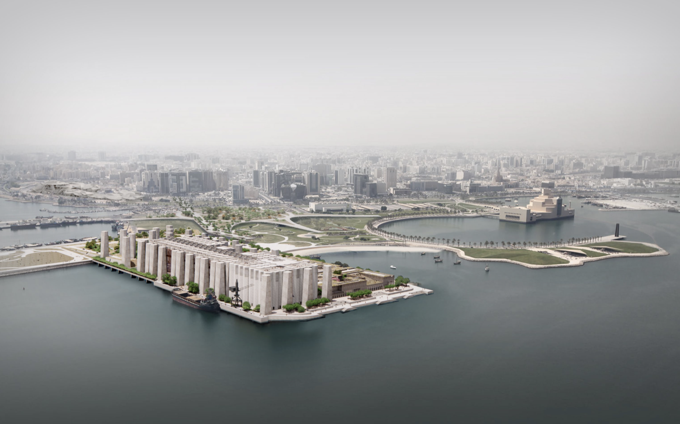

DOHA, QATAR, 3 October 2022 — On the occasion of the FIFA World Cup Qatar 2022™ and the year-round national cultural movement Qatar Creates, Qatar Museums will present the special exhibition Art Mill Museum 2030, on view to the public from 24 October 2022 through 30 March 2023 at the Qatar Flour Mills Warehouse and the recently renovated Al Najada Heritage House #15 in Doha. Looking ahead towards the opening of the Art Mill Museum [مطاحن الفن Matahen Alfan] in 2030, the exhibition will introduce the concept of the museum, the architectural project by ELEMENTAL, led by Pritzker Prize-winning architect Alejandro Aravena, and the garden design.

Completing a cultural district that already comprises the Museum of Islamic Art, MIA Park and the National Museum of Qatar, the Art Mill Museum will house an exceptional and international art collection assembled over the past 40 years, with multidisciplinary works of great diversity dating from 1850 to the present. In a main building of 80,000 square meters (including 23,000 square meters of gallery spaces), the Art Mill Museum will offer visual art icons as well as architecture and design, films and film props, fashion, crafts, and much more. A pioneering institution in the non-Western world, it will represent the modern and contemporary arts of all regions of the globe on an equal basis, engaging local and international audiences alike through multiple narratives of art history. The museum concept has been developed by art historian and museum director Catherine Grenier and the prefiguration team. A signature public garden is designed by VOGT Landscape Architects, led by Günther Vogt. A creative village for arts, crafts and design will provide recreational, learning and production resources for the general public and for the creative communities of Qatar and beyond.

Her Excellency Sheikha Al Mayassa bint Hamad bin Khalifa Al Thani, Chairperson of Qatar Museums, said, “As visitors from around the world come to Doha for Qatar Creates and the FIFA World Cup Qatar 2022, we are thrilled to take the public behind the scenes, revealing the complex and fascinating process of how we are developing an institution that will be one of the world’s leading museums of modern and contemporary art. The Art Mill Museum is the conclusion of a twenty-five-year cultural plan. It will place Arab modern and contemporary art in the context of global art, allowing us to further engage with the rest of the world by creating new, unexpected narratives."

The Art Mill Museum Concept Director commented: “The Art Mill Museum will be Qatar’s museum of modern arts and cultures, presenting the nation’s world-class, international collections from the 19th century to today. It is too early to present the extensive collections, but we are delighted to propose this sneak preview of the museum development process at this key stage prior to construction. Art Mill Museum 2030 allows us to present the ideas and artistic viewpoint for the museum, the landmark architecture, the garden and the creative village. This development of the museum beyond its walls will include spaces for creativity, performance, coworking, art education, and varied leisure spaces for local and international audiences.”

Grenier continued, “Visitors will have access for the first time ever to a part of the flour mill where the project will emerge. The exhibition includes several new specially commissioned artworks that distinctly consider the flour mill and its current industrial activities as a subject. We are collectively creating a shared archive with memories of this significant site before its transformation.”

The exhibition Art Mill Museum 2030, which will present the vision of the museum, the architectural project, and the signature garden, will be on view in two locations: the site of the flour mill on Doha’s Corniche, built in the 1990s, that is being creatively reimagined as the site of the museum, and Al Najada Heritage House #15. Each venue will present different aspects of the development of the Art Mill Museum and be free of charge for visitors.

Site 1: From Flour to Art
The installation From Flour to Art introduces the vision for the museum and gives the public its first opportunity to enter what will be part of the future complex. Visitors will see how the architect Alejandro Aravena and ELEMENTAL will reimagine the existing building, characterised by its spectacular concrete silos, to produce a museum that incorporates a creative village and public garden. The evolution of the project, from the international design competition in 2016 to now, will be revealed through an engrossing display that includes original models, drawings and renderings.

To reflect the transformation of the site and demonstrate how the Art Mill Museum will be a place for contemporary creativity, artists have been commissioned to create films and photographs establishing the parallels between the flour mill and the future museum. The commissioned artists are Yasmina Benabderrahmane (1983, France – works in Paris), Mohammed Kamal Al Emadi (1988, Qatar – works in Doha), François-Xavier Gbré (1978, France – works in France and Côte d’Ivoire), Ali Kazma (1971, Turkey – works in Istanbul and Paris), Amal Al Muftah (1994, Qatar – works in Doha), Shaima Al-Tamimi (1984, Yemen/Kenya – works in Qatar).

Site 2: The Museum’s Garden
The second part of Art Mill Museum 2030, titled The Museum’s Garden, is installed at Al Najada Heritage House #15, a recently renovated house near Souq Waqif. This presentation is devoted to the development of the signature garden of the Art Mill Museum, designed by VOGT Landscape Architects, and its inspirations. A display of VOGT’s drawings and a selection of beautifully illustrated reference books from the collection of Qatar Museums and loans from Qatar National Library and from Mathaf: Arab Museum of Modern Art, will highlight the reinterpretation of traditional Islamic gardens. Also on view will be two artworks: a mosaic by Hamra Abbas (1976, Kuwait – works in Lahore, Pakistan) and a commissioned film by Amal Al Muftah (1994, Qatar – works in Doha) produced in collaboration with Doha Film Institute (DFI).

For information about the public programme in conjunction with Art Mill Museum 2030 please contact: education@qm.org.qa.

The Art Mill Museum Director of Concept is Catherine Grenier, art historian and museum director. Hafid Rakem is the Director of Museum Architecture Development and Caroline Hancock is the Senior Curator of Modern and Contemporary Art.

The exhibition Art Mill Museum 2030 is curated by Aurélien Lemonier, Art Mill Museum Curator of Architecture, Design and Gardens, with Maryam Hassan Al Thani, Curator, Qatar Museums Exhibitions Department. The exhibition’s Project Manager is Malak Hassan, Qatar Museums Exhibitions Department. Commissions for the exhibition have been managed by Clémence Bergal, Art Mill Museum Head of Collections and Commissions.

The exhibition has been designed by Studio Adrien Gardère, Paris, also the museographer of the Art Mill Museum. A catalogue of the exhibition, edited by Aurélien Lemonier, Maryam Hassan Al Thani, and Caroline Hancock will be published by Qatar Museums. Exhibition graphics and catalogue design are by 2x4, New York.

Image Caption: ELEMENTAL, Art Mill Museum conceptual design: view from the South (Doha, Qatar), 2022, Rendering, Courtesy of Qatar Museums

Practical Information

Site 1 – Qatar Flour Mills Warehouse: “From Flour to Art”
Address: Qatar Flour Mills Warehouse, Doha Corniche
Times: Saturday to Thursday 10:00 to 17:00, Friday 14:00- 19:00
Prior reservations are necessary on Qatar Museums website.

Site 2 – Al Najada Heritage House # 15: “The Museum’s Garden”
Address: Al Najada District, Old Doha
Times: Saturday to Thursday 10:00 to 17:00, Friday 14:00- 19:00
Prior reservations are necessary on Qatar Museums website.

Art Mill Museum 2030 is part of Qatar Creates — the year-round national cultural movement that curates, promotes, and celebrates the diversity of cultural activities in Qatar; connecting resident and global audiences with Qatar’s creative industries.

About Qatar Museums
Qatar Museums (QM), the nation's preeminent institution for art and culture, provides authentic and inspiring cultural experiences through a growing network of museums, heritage sites, festivals, public art installations, and programmes. QM preserves, restores, and expands the nation's cultural offerings and historical sites, sharing art and culture from Qatar, the Middle East, North Africa, and South Asia (MENASA) region with the world and enriching the lives of citizens, residents, and visitors.

Under the patronage of His Highness the Amir, Sheikh Tamim bin Hamad Al Thani, and led by its Chairperson, Her Excellency Sheikha Al Mayassa bint Hamad bin Khalifa Al Thani, QM has made Qatar a vibrant centre for the arts, culture, and education in the Middle East and beyond. QM is integral to the goal of developing an innovative, diverse, and progressive nation, bringing people together to ignite new thinking, spark critical cultural conversations, educate and encourage environmental stewardship and sustainable practices, and amplify the voices of Qatar's people. Since its founding in 2005, QM has overseen the Museum of Islamic Art and MIA Park, Mathaf: Arab Museum of Modern Art, the National Museum of Qatar, QM Gallery Al Riwaq, QM Gallery Katara, 3-2-1 Qatar Olympic and Sports Museum, and Dadu, Children's Museum of Qatar.

Through its newly created Creative Hub, QM also initiates and supports projects—such as the Fire Station Artist in Residence, the Tasweer Qatar Photo Festival and the creative hub for innovation, fashion and design M7—that nurture artistic talent and create opportunities to build a strong and sustainable cultural infrastructure.

Animating everything that Qatar Museums does is an authentic connection to Qatar and its heritage, a steadfast commitment to inclusivity and accessibility, and a belief in creating value through invention.

About Qatar Creates
Qatar Creates curates, celebrates, and promotes cultural activities within Qatar.
Working with partners in museums, film, fashion, hospitality, cultural heritage, performing arts, and the private sector in Qatar, the Qatar Creates platform amplifies the voice of Qatar’s creative industries, directly connecting audiences to events.

Press Contacts:
Ruth Frankel, Polskin Arts: ruth.frankel@finnpartners.com (+1 646 213 7249)
Salma Sadek, Qatar Museums: ssadek@qm.org.qa (+974 3141 0110)

