MATHAF: ARAB MUSEUM OF MODERN ART UNVEILS FOUR EXHIBITIONS SHOWCASING ARTISTS FROM ACROSS THE REGION

Line Up Includes Qatari American artist Sophia Al-Maria’s First Major Exhibition in the Middle East, Retrospective of Palestinian artist Taysir Batniji, A Tale of Two Tigers featuring Singaporean artist Ho Tzu Nyen and artefacts relating to Tipu Sultan, and a Celebration of a New Generation of Qatari Artists

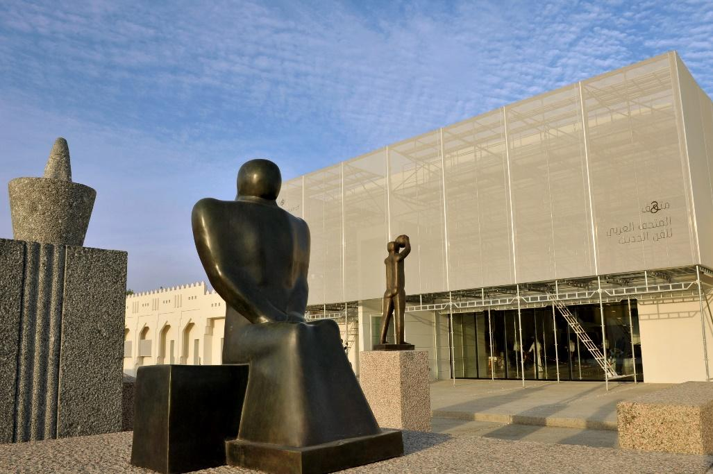

DOHA, QATAR, 15 September 2022 — Under the patronage of Her Excellency Sheikha Al Mayassa bint Hamad bin Khalifa Al Thani, Chairperson of Qatar Museums, His Excellency Sheikh Hassan bin Mohammed bin Ali Al-Thani, President of Mathaf: Arab Museum of Modern Art, today inaugurated four art exhibitions at the museum. The exhibitions form part Qatar Creates and reflect the creative power and heritage of the Middle East, North Africa, South Asia (MENASA) region in celebration of Qatar-MENASA Year of Culture 2022, an international cultural exchange designed to deepen understanding between nations and their people.

The exhibitions are Sophia Al-Maria: INVISIBLE LABORS daydream therapy; Taysir Batniji: No Condition is Permanent; One Tiger or Another, a research exhibition for a major new project, Rubaiyat Qatar, an art quadrennial that will be presented in its inaugural edition across Qatar in 2024; and a group show featuring works from alumni of the Fire Station’s Artist in Residence program called Majaz: Contemporary Art Qatar.
Her Excellency Sheikha Al Mayassa bint Hamad bin Khalifa Al Thani, Chairperson of Qatar Museums, said, “For more than a decade, Mathaf has amplified the voices of artists who share cultural and historical connections with Qatar, and has inspired our local community by providing exposure to artists offering Arab perspectives. Mathaf fulfils this mission through a diverse selection of exhibitions, whether Qatari-American artist Sophia Al-Maria with her first show in the region, Taysir Batniji’s work centred on his time living in Palestine or works from alumni of the Fire Station’s Artist in Residence programme whose creations may be their first to appear in a museum, these exhibitions reinforce that there is no one Arab voice, perspective, or experience. Rounding out the programme at Mathaf is our first exploration into an exciting new initiative, Rubaiyat Qatar, which will transform Qatar into a nationwide exhibition of contemporary Arab art every four years, debuting in 2024.”

Zeina Arida, Director of Mathaf: Arab Museum of Modern Art, said, “We are thrilled to present a programme encompassing a diverse cross-section of exceptional contemporary Arab artists whose backgrounds span borders and whose works utilise a variety of disciplines and subjects. Mathaf is the modern art hub in Qatar where visitors can interact and experiment with new art forms from contemporary artists. As Qatar prepares to welcome guests for the FIFA World Cup Qatar 2022, we are grateful to have this important platform for artists across the region to be able to introduce themselves and their art on the global stage."

SOPHIA AL-MARIA
INVISIBLE LABORS daydream therapy
16 September 2022 – 21 January 2023
This exhibition brings together existing and new works for the Qatari American artist’s first major museum exhibition in the Middle East. For this show, Al-Maria, (b. 1983) invites a group of artists, curators, scholars, and communities into a dialogue around histories and futures and the Gulf’s relation to the surrounding regions. INVISIBLE LABORS daydream therapy foregrounds the importance of storytelling and speculative narratives as strategies of survival, imagination and reclaiming (hi)stories. The exhibition consists of installations, video-work, commissioned soundscapes, workshops, conversations, drawings and online screening and meetings.

“In 2007, I interviewed my uncle who at the time had just gotten a job as a security guard at hamad hospital about his dreams. In preparation for this show I found this relic and it moved me tremendously. This sweet moment of possibility and the bittersweet contents of it made me reflect on how none of his dreams had come true in the close to 20 years since. At a time when the ‘collective vision’ of what our future will look like is in the hands of very few, it is more important than ever to listen directly to the many dreamers,” said Al Maria.

The exhibition, which consists of a variety of media including installations, video-work, and commissioned soundscapes, centralizes the importance of storytelling and speculative narratives as strategies of survival, imagination, and reclaiming stories. The exhibition is curated by researcher and independent curator Amal Alhaag in collaboration with Mathaf's assistant-curator Abdulrahman Mohammed Alkubaisi. "With INVISIBLE LABORS daydream therapy, Sophia offers visitors, collaborators, and participants a poetic, intimate, and visually enriching journey—interwoven with pressing societal questions, such as (inter)generational labor issues, migratory dreams, and interpersonal histories. The exhibition functions as a caretaker of dreams and daydreamers. After all, when we ask how dreams can be a catalyst for rekindling radical forms of solidarity across differences, we must go beyond cliches of solidarity and decentralize our privileges and (dis)comfort,” said Alhaag.

Taysir Batniji: No Condition is Permanent
16 September 2022 – 21 January 2023
Presented within a global context of social uncertainty and fragility of historical narratives, the exhibition is conceived as a reflective space dedicated to the artist Taysir Batniji (b. 1966 Gaza). The show is a survey of his art created between 1997 and 2022. During this period, the artist lived in France, but his life and work meditate on Palestine. The exhibition looks at Batniji’s diverse practice using photography, drawing, video, installation and performance, and is co-curated by Abdellah Karroum and Lina Ramadan.

“My journey in the last twenty years has been a series of interruptions and beginnings. Whether I’m here [France] or there [Palestine], I always find myself starting from point zero when things stop completely…I find my work making references to art history, and by doing so it organically allows artworks to not be constrained by closed definitions of identity, belonging. I’m found of art schools that influence both my work and thinking as I feel it communicates with artists and creates a continuity of exchanges'' said Batniji.

Commenting on the exhibition, Karroum said: “Taysir Batniji’s show at Mathaf resonates with the multicultural city that Doha is becoming today as an urban space under transformation. I see the artist as a global citizen with deep awareness of the major crises that the world is going through at ecological, social, and political levels. His works are often inspired by personal experience that strongly reflects on the entire humanity, with a sense of empathy towards its uncertain future.

“Taysir Batniji’s remarkable experimentation between practice and art history interrogates artists of his time responding to unsettling environments and forms. In No Condition Is Permanent we present a space for reflection on social aspirations, but also firmly open engagements with rooted matters including the struggle for freedom and systematic oppression of indigenous rights which shake our existence every day” said Ramadan.

Majaz: Contemporary Art Qatar
16 September 2022 – 25 February 2023
This exhibition celebrates five years of the Artist in Residence (AIR) programme at the Fire Station in Doha and the flourishing art scene in Qatar. In January 2021, the Fire Station invited 14 AIR alumni to participate in a six-month-long programme to develop new works for this exhibition. An additional 25 AIR alumni are featured in the exhibition, where they showcase works in a variety of disciplines including painting, sculpture, and new media while exploring different perspectives and reflections to unveil personal, cultural, and global concepts. The works will be displayed in dialogue with each other highlighting various elements of storytelling. The exhibition is curated by Saida Al Khulaifi, Acting Head of Residency Programmes and Amal Zeyad Ali, Exhibitions Coordinator at the Fire Station.
“The Artist in Residence programme at the Fire Station supports the creative development of emerging and mid-career artists and helps to promote local contemporary art. Majaz: Contemporary Art Qatar is a celebration of this programme and its alumni and an invitation to local and international audiences to view more than 80 artworks in one space,” said Al Khulaifi.

One Tiger or Another
16 September 2022 – 21 January 2023

Featuring a cannon, a contemporary video installation, 18-century paintings and contemporary comic books, this exhibition, curated by Tom Eccles and Mark Rappolt explores history as the product of both fact and fiction, through a CGI-animation by Singaporean artist Ho Tzu Nyen (b. 1976) and artefacts relating to the legend of Tipu Sultan, the Tiger of Mysore, one of the most famous and polarizing figures in South Asian history, across mediums and time.
Expanding on themes introduced by Ho’s two-channel video, One or Several Tigers, and anchored by the story of Tipu Sultan, the exhibition explores the creative potential of art and media as a means of storytelling and the shaping and reshaping of identity. Moreover as it explores the iconography of the tiger in relation to both South and Southeast Asian history, it questions the boundaries between fact and fiction, between coloniser and colonised, and looks at how the same story can be told and retold. In doing so, it challenges the idea that both history and art are about fixed and stable perspectives and conventional notions of centres and peripheries of power.

Tom Eccles comments about the work methodology and intention behind the exhibition, stating that “bringing together contemporary art with historical collections invigorates both. This exhibition demonstrates the depth of Qatar Museums’ collection and creates a lens through which to view how the past is always present.”

Led by Artistic Directors Tom Eccles and Mark Rappolt, Assistant Curator Jumanah Abbas, and Director of Rubaiyat Sheikha Alanood Hamad Al Thani, this emblematic exhibition forms part of the initial research for Rubaiyat Qatar. A major new project under Qatar Museums, Rubaiyat Qatar is a nationwide multidisciplinary quadrennial exhibition. Leading up to its inaugural edition in 2024 is a series of pop-up exhibitions and residencies that will introduce local communities to the themes and practices related to its inaugural 2024 exhibition.

Products inspired by the exhibitions are on sale at the Qatar Museums’ gift shop at Mathaf and on the IN-Q website: www.inq-online.com. Items purchased online ship worldwide via DHL.

Mathaf: Arab Museum of Modern Art
Mathaf: Arab Museum of Modern Art serves as the Arab world's leading modern and contemporary art museum. The Museum offers a welcoming, vibrant environment that invites evolving discussions about modern art in the region and beyond. Home to a permanent collection that offers a distinctively unique comprehensive overview of modern and contemporary art from North Africa and the Middle East, Mathaf ("museum" in Arabic) also performs a vital role as a centre for dialogue and scholarship and a resource for fostering creativity. Mathaf was opened in 2010 by QM in partnership with Qatar Foundation (QF) and is located in Education City. The Museum was founded by H.E. Sheikh Hassan bin Mohammed bin Ali Al Thani, who began collecting in the 1980s with the acquisition of works by Qatari artists. Sheikh Hassan later broadened his focus to include works by 20th-century artists throughout the Middle East, North Africa, and the Arab Diaspora and objects that inspired many Arab modern artists, such as pre-Islamic works from ancient Mesopotamia and Egypt. An initial group of works assembled by Sheikh Hassan was donated to the public institution. Over the past decade, Mathaf made major contributions to research and debate around modern and contemporary art, made available to scholars and audiences through the Mathaf Encyclopedia of Modern Art and the Arab World. The Museum evolved into a meeting point for scholars from across the region around education programmes, conferences, and publications. It has served as a dynamic platform for artists by facilitating the creation and exploration of contemporary works.

